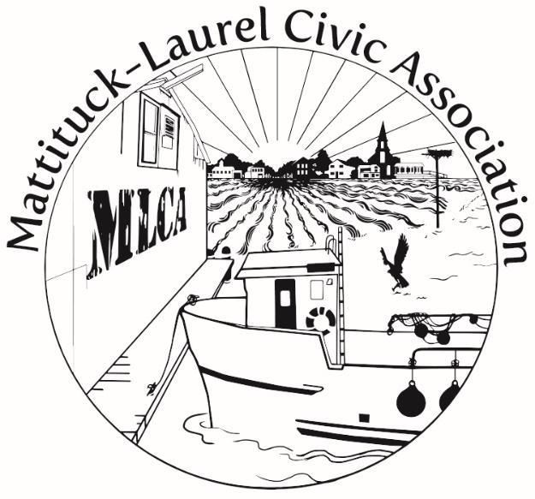
MLCA’s February Monthly Meeting Is on Zoom

Monday, February 22, 2021

6:30 p.m. to 8 p.m.

An Introduction to North Fork Dark Sky Week April 5-12, 2021

Learn about the beauty and value of nighttime darkness, and the Town’s “dark sky” artificial lighting code.

Also on the agenda: An update on the Town’s recently completed Mattituck hamlet traffic study and the latest on the Town’s Comprehensive Plan

For Zoom link, click here

